Project Synopsis

on

**Online Marketplace**

Submitted as a part of course curriculum for

**Bachelor of Technology**

in

**Computer Science**



**Submitted by**

Aman Tyagi

Abhishek Kaushik

**Under the Supervision of**

Prof. Pallavi Sharma

**KIET Group of Institutions, Ghaziabad**

**Department of Computer Science**

**Dr. A.P.J. Abdul Kalam Technical University**

**2022-2023**

**DECLARATION**

We hereby declare that this submission is our work and that, to the best of our knowledge and belief, it contains no material previously published or written by another person nor material which to a substantial extent has been accepted for the award of any other degree or diploma of the university or other institute of higher learning, except where due acknowledgement has been made in the text.

Signature of Students:

Name : Aman Tyagi Abhishek Kaushik

Roll No. : 2000290120020 2000290120010

Date :

**CERTIFICATE**

This is to certify that Project Report entitled “**Online marketplace**” which is submitted by **Abhishek Kaushik Aman tyagi** in partial fulfilment of the requirement for the award of degree B. Tech. in Department of Computer Science of Dr A.P.J. Abdul Kalam Technical University, Lucknow is a record of the candidates own work carried out by them under my supervision. The matter embodied in this report is original and has not been submitted for the award of any other degree.

**Date: Supervisor Signature**

**ACKNOWLEDGEMENT**

It gives us a great sense of pleasure to present the synopsis of the B. Tech Mini Project undertaken during B.Tech. Third Year. We owe a special debt of gratitude to Prof. Pallavi Sharma (Professor), Department of Computer Science, KIET Group of Institutions, Delhi- NCR, Ghaziabad, for his/her constant support and guidance throughout the course of our work. Her sincerity, thoroughness and perseverance have been a constant source of inspiration for us. It is only his/her cognizant efforts that our endeavours have seen the light of the day.

We also take the opportunity to acknowledge the contribution of Dr. Ajay Kumar Shrivastava, Head of the Department of Computer Science, KIET Group of Institutions, Delhi- NCR, Ghaziabad, for his full support and assistance during the development of the project. We also do not like to miss the opportunity to acknowledge the contribution of all the faculty members of the department for their kind assistance and cooperation during the development of our project.

Last but not the least, we acknowledge our friends for their contribution to the completion of the project.

Signature:

Date :

Name : Aman Tyagi Abhishek Kaushik

Roll No : 2000290120010 2000290120020

**ABSTRACT**

There are a number of shops in our nearby areas most of them are not registered on online platforms like Flipkart , Amazon etc. due to more paper work and they are incapable of do delivery at remote locations. and because of that if a person have to buy something and he/she don’t know about that, will search it on online stores or ecommerce websites but at that time sometimes that maybe out of stock or may not be available on the website and their delivery is not available in villages also. If all the shopkeepers are registered on a platform which contain all information about their shop including location and contact numbers and items which they sell. So peoples know about all shops and mostly time buy product from them and if people from outside come for shopping in market they not have a little bit of knowledge about shops so by use of our website they found items of their choice and get location of the shop and on the based of rating of shops buy product easily and due to this the profit of the seller also increases and the trend of online shopping not affecting the shopkeeper too much. and shopkeeper also do the delivery in local areas if they want this sort out all the problems of the local customer .The user can register and get connected with the registered merchants and it will show all the available products and also it will show the price in sorted manner. Also the interface of the website will be user friendly.

**TABLE OF CONTENTS**

|  |  |  |
| --- | --- | --- |
|  | | Page No. |
| TITLE PAGE .................................................................................................................... | | i |
| DECLARATION .............................................................................................................. | | ii |
| CERTIFICATE …........................................................................................................... | | iii |
| ACKNOWLEDGEMENT.................................................................................................. | | iv |
| ABSTRACT...................................................................................................................... | | v |
| LIST OF FIGURES ......................................................................................................... | | vi |
| LIST OF ABBREVIATIONS ……….…………………………………………………. | | vii |
|  | |  |
| CHAPTER 1 INTRODUCTION | | 1-n |
| 1.1.          Introduction ……………………................................................... | | 1 |
| 1.2 Problem Statement.……………………....................................... | | 1 |
| 1.3.          Objective………………………………………………………… | | 1 |
| 1.4.          Scope……………………………………………………………. | | 1 |
| CHAPTER 2 TECHNOLOGY USED ………..………………………..………………. | | 7-p |
| CHAPTER 3 PROPOSED METHODOLOGY …………………………………........ | | 8-m |
| 3.1 Flowchart | |  |
| 3.2 Algorithm Proposed | | 10 |
| CHAPTER 4 LITERATURE REVIEW……………………………………………....  CHAPTER 5 CONCLUSION …....................................................................................... | | 12 |
|  |
|  | |  |
|  | |  |

**Chapter 1: Introduction**

* 1. **Introduction**

In this project, we will be making a website which will consist of data of the small and medium scale merchants those who are not connected through any online medium . In many parts of the country there are people who have the services available in their nearby but do not know about that and due to which they spends more time and money in that particular thing and peoples come from outside not have knowledge of shops in that market they also find shops according to their requirement and this is profitable for shopkeepers also.

* 1. **Problem Statement**

Our problem statement in simple words would be like:

* This website will be helpful for the user who are new to a place.
* Also to the merchant who are not known that much and sells a variety of products.
  1. **Objective**

Our objective is to pro vide a machine learning model which do the following :

* Show the merchant and what kind of product is sold by him.
* Take the data of a merchant and
* Take the requirement of user,
* Will suggest the nearest merchant to user and all the shops of that area in the sorted order of ratings.
* Also suggest the best price for the user & user can also compare the price with different ecommerce websitesand shops on that platfrom also.
  1. **Scope**

After discussion with the team and with our guide, we can consider the scope of this project as follows :

* This is useful in mostly the rural areas where even ecommerce websites are unable to reach.
* Also useful in large markets where people from different regions come for shopping.

**TECHNOLOGY USED:**

**WEBSITE DEVELOPMENT**

**React js**

React is a JavaScript library for building user interfaces React is used to build single-page applications. React allows us to create reusable UI components.

The React. js framework is an open-source JavaScript framework and library developed by Facebook. It's used for building interactive user interfaces and web applications quickly and efficiently with significantly less code than you would with vanilla JavaScript.

**Node js**

It is used for server-side programming, and primarily deployed for non- blocking, event-driven servers, such as traditional web sites and back-end API services, but was originally designed with real-time, push-based architectures in mind.

Node.js is an open source server environment. Node.js allows you to run JavaScript on the server.

**CSS(Cascading Style Sheet)**

### Cascading Style Sheets (CSS) is a language used to describe the presentation of a document written in  (including XML dialects such as  . CSS describes how elements should be rendered on screen, on paper, in speech, or on other media.

### CSS is among the core languages of the open web and is standardized across Web browsers according to . Previously, the development of various parts of CSS specification was done synchronously, which allowed the versioning of the latest recommendations. You might have heard about CSS1, CSS2.1, or even CSS3. There will never be a CSS3 or a CSS4; rather, everything is now CSS without a version number.

### Material UI

### React community provides a huge collection of advanced UI component framework. Material UI is one of the popular React UI frameworks. Let us learn how to use material UI library in this chapter.

**MACHINE LEARNING**

Used a machine learning algorithm which takes data of the item sold by user and tell . user which item is most sold and which item is not

**DIAGRAM/FLOWCHART:**

Get Chat Dashboard

And contact information

Update their items and check any request of products from customer.

Seller Dashboard

Seller

Customer

Dashboard

See wide range of product in different shops and buy accordingly

Customer

Register and Login Page

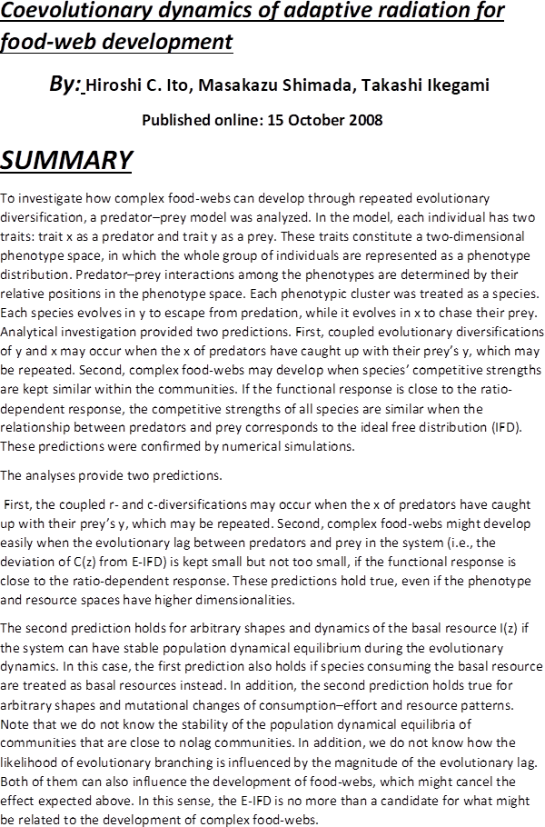 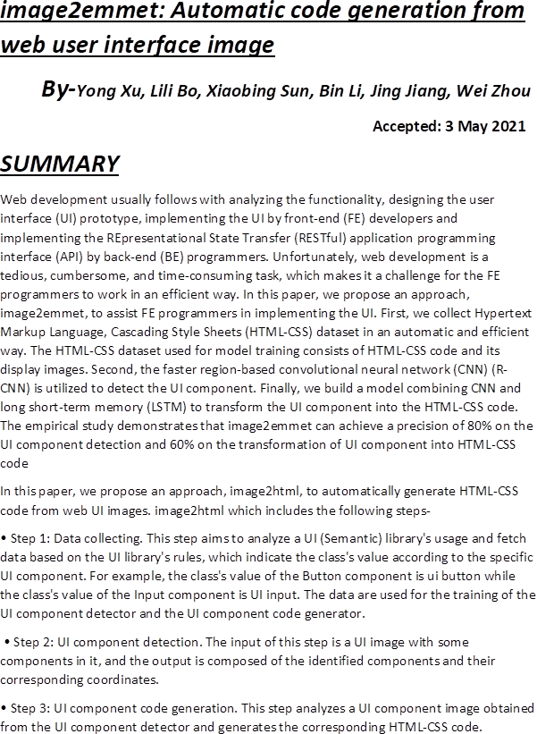 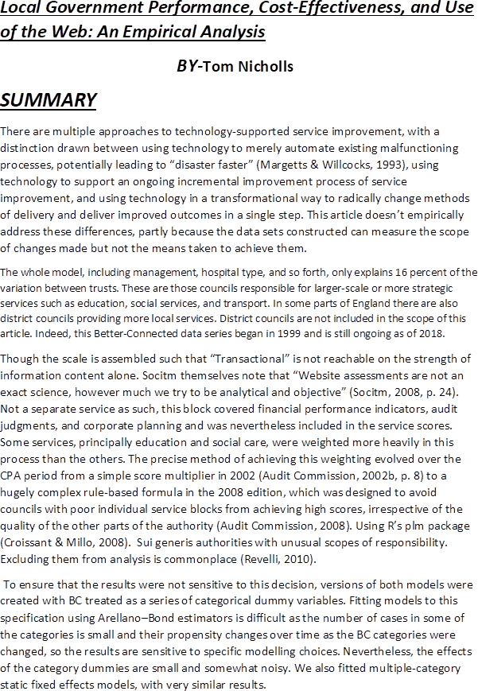 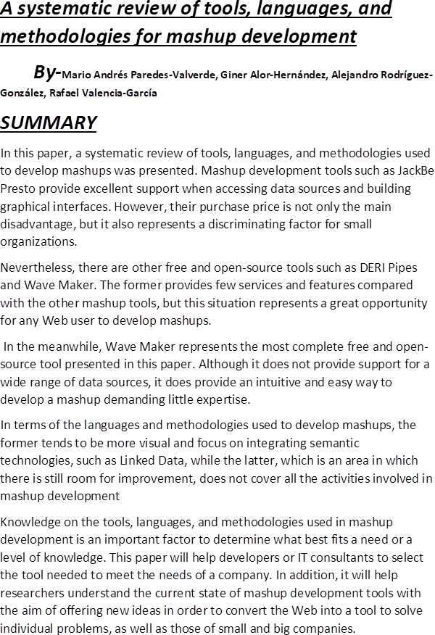 

**Conclusion:**

We have developed a website which is helpful for a user as well as shopkeeper